FANoFAN
E-Project
Deveoper Guide
Supervisor: Miss Mahnoor
Group Member
Enrolment ID | Name
Student1691666 | Areeba Saleem
Student16885546 | Kanwal Khan
Student1691661 | Naveed
Student1691668 | Hussain
Student1692437 | Mudasir

Curriculum:7144
Batch Code:2507E8

Semester: 1st semester(ADSE)

Explore Premium Cooling with FANoFAN

“FANoFAN is an e-commerce and informational website designed to showcase a wide range of high-quality fans, including ceiling, wall, and pedestal models. The website provides clear product images, detailed specifications, pricing information, and easy navigation to help users quickly find the fan that suits their needs. It also includes features such as add-to-cart functionality, downloadable product details, and a responsive layout for smooth browsing on all devices. Overall, FANoFAN aims to deliver a simple, user-friendly, and reliable online experience for customers looking for cooling solution”

Objectives of the Website

- Provide detailed information about different types of fans.
- Offer an easy and smooth online shopping experience.
- Display clear product images, specifications, and prices.
- Enable users to add products to the cart and download product details.
.

Problem statement
FANoFAN Company is into manufacturing and selling on Fans. They manufacture fans
for various needs of customers. From Ceiling Fans to Table Fans to Exhaust Fans,
they are into all types of Fan Manufacturing.
They are looking to come up with their own website and display all the products
available with them. They want to provide a detailed information about all their
products.
Requirement Specification:
The Web site is to be created based on the following requirements.
1) The Home Page should be created making use of Sections with a suitable
logo, the header section can be added which will show images Fans.
2) The site must contain the links to navigate through any category for the
information.
3) Links of bottles can be categorized like (Ceiling Fans, Table Fans, Exhaust
etc.)
4) Specification and Pricing of Fans can be added along with the images.
5) Gallery section can be added for viewing different images.
6) Feedback must be allowed to enter by the viewer
7) Site map, Gallery, about us, Queries link, Contact us link must be added.
8) The complete description must be allowed to get download as pdf or doc file.
9) The advertise section with various facilities provided should be mentioned.

Hardware/ Software Requirements

- A minimum computer system that will help you access all the tools in the
courses is a Pentium 166 or better
- 64 Megabytes of RAM or better
Software [Either or Combination as per Course/Sem]
• Notepad/HTML editor/CoffeeCup
• Angular / Angular JS / React / BootStrap
• Dreamweaver / Figma
• MS IE / Chrome / FireFox / Netscape /MS Edge

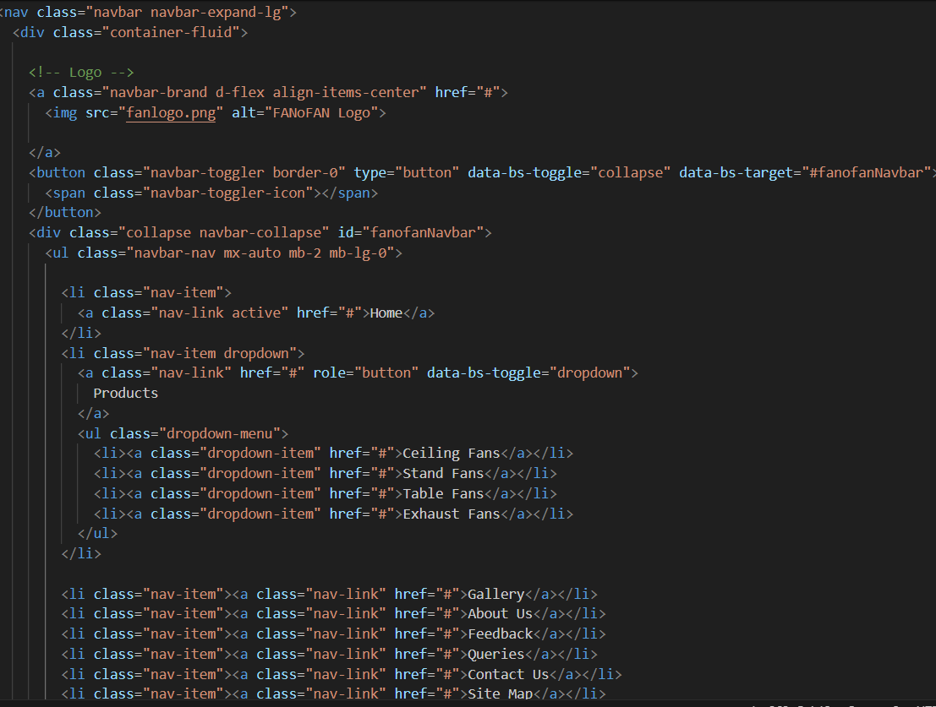
- Navigation Bar(navbar.html)
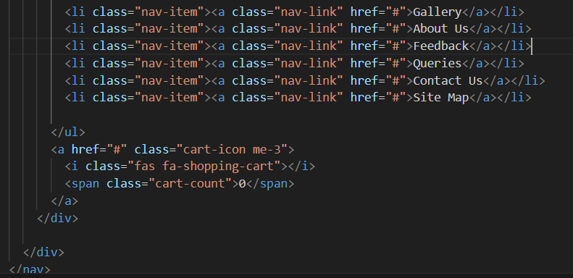

- Our navbar helps users move easily between important pages like Home, About, Gallery, Contact, etc.
- It is commonly shown at the top of a website for quick access.
- This navbars contain the website logo, menu links.
- Its Improves usability and mobile responsiveness.

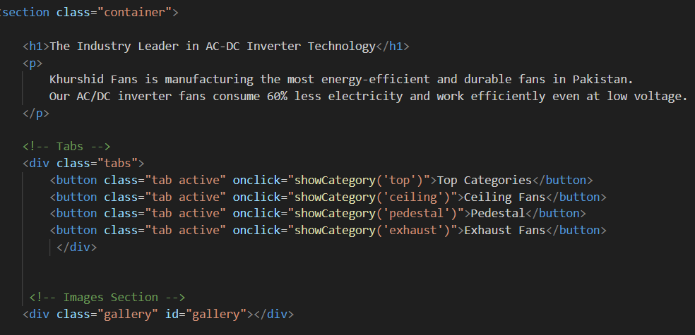
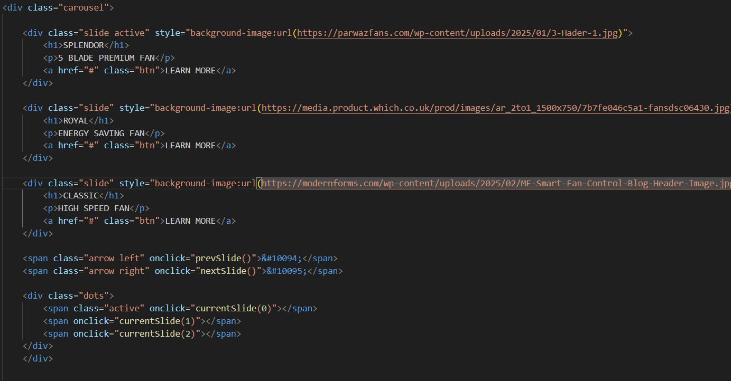
- Home (home.html)
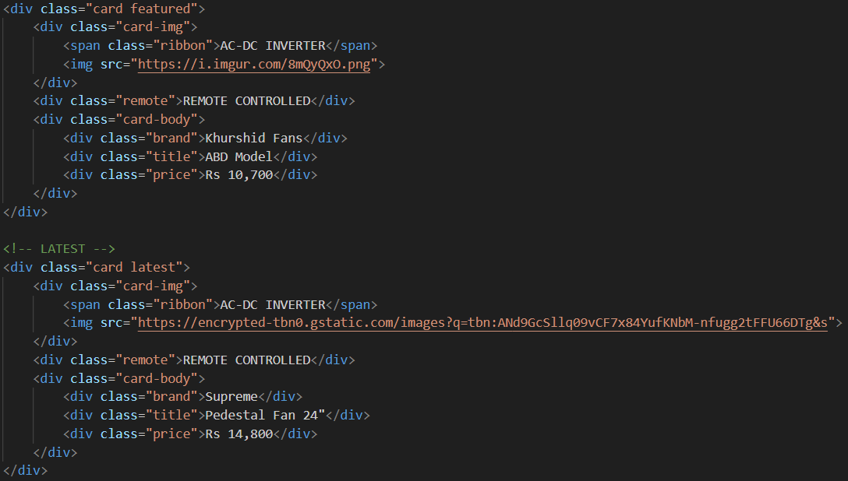
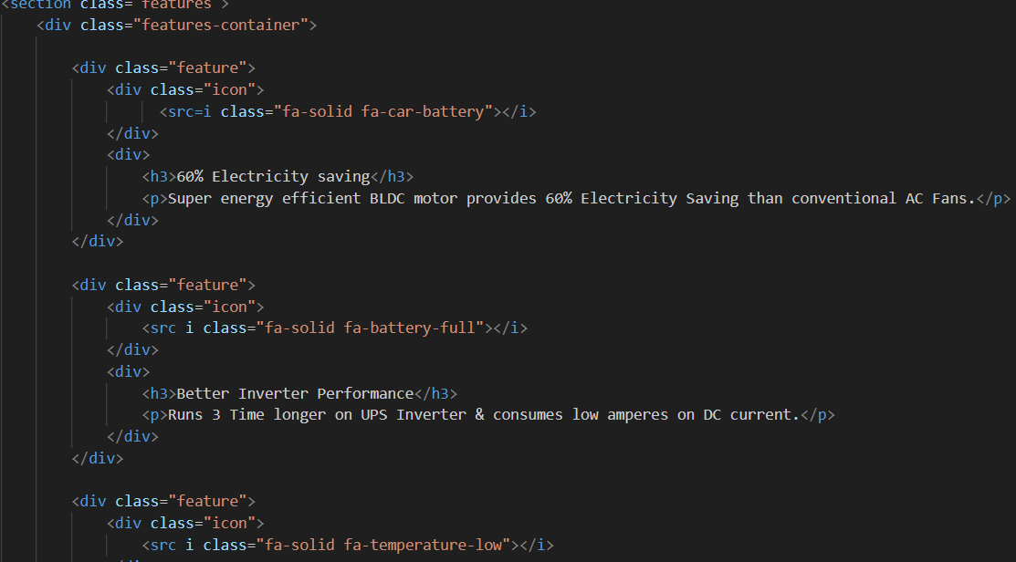
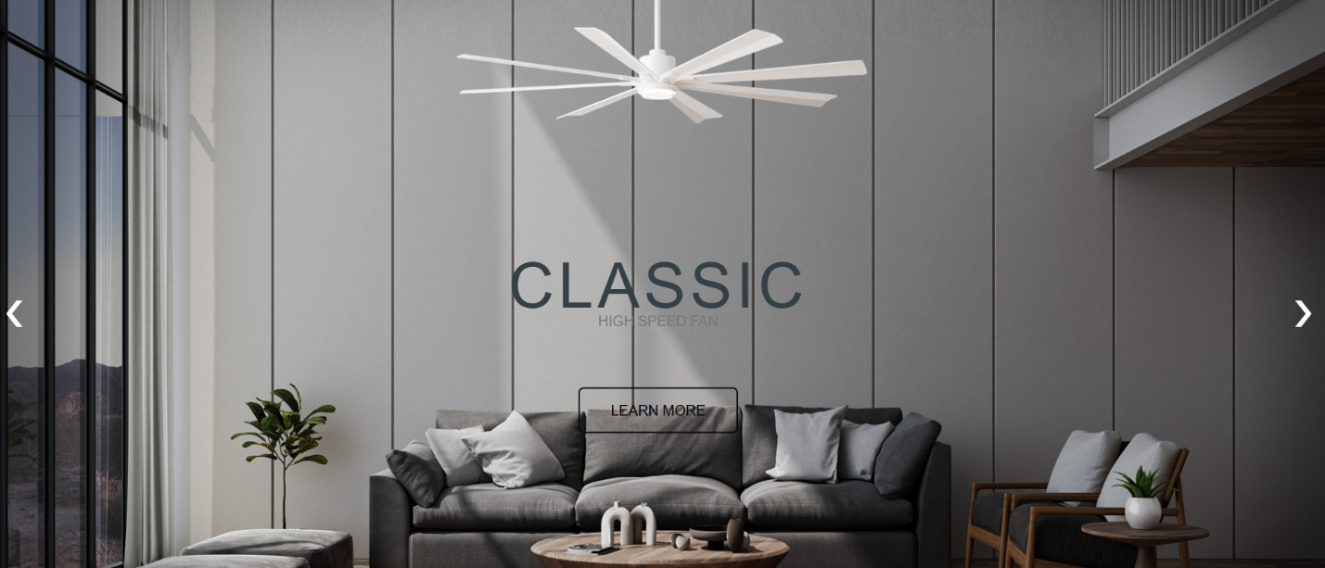
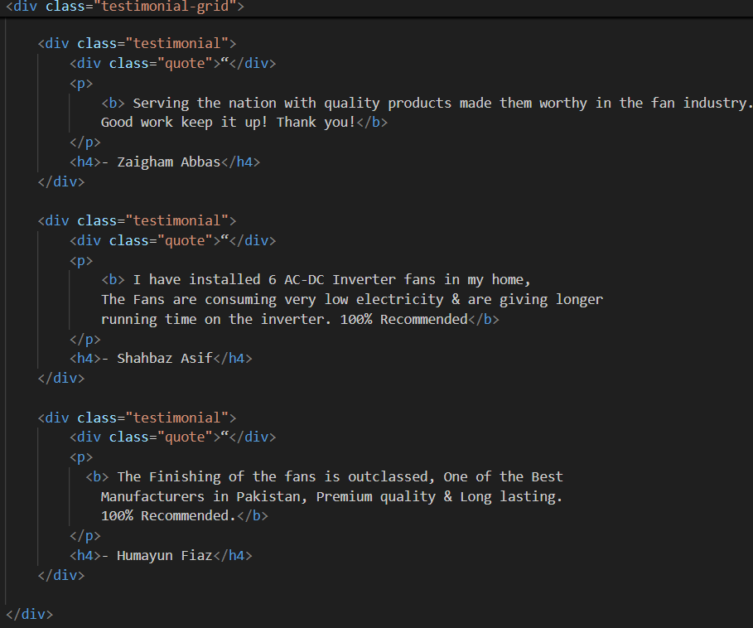

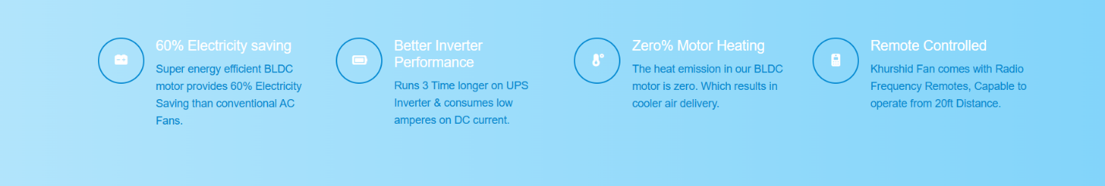
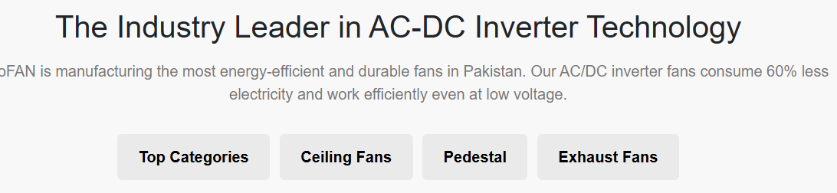
“The Home Page is the main entry point of the FANoFAN website where users get a quick overview of the brand, products, and important features. It includes the navigation bar, featured fan designs, highlights of services, and easy access to other pages like Gallery, Feedback, and Queries. A clear and attractive home page helps visitors understand the website purpose and quickly find the information they need.“

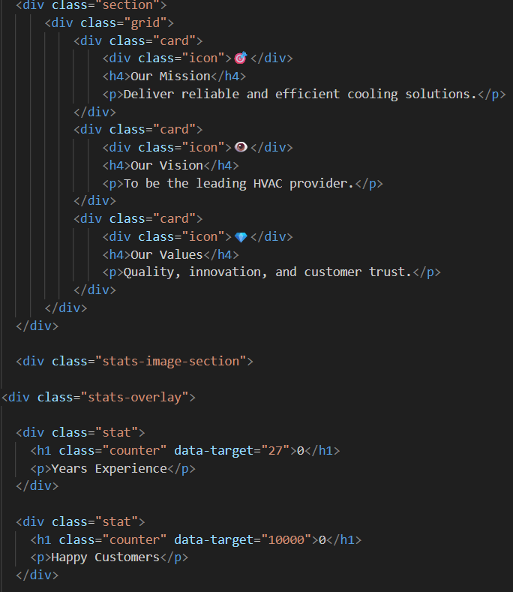
3.About Us(about.html)
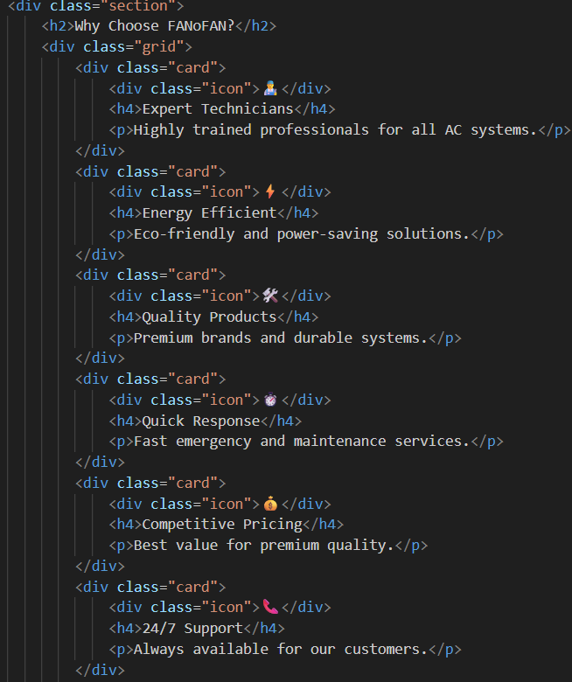
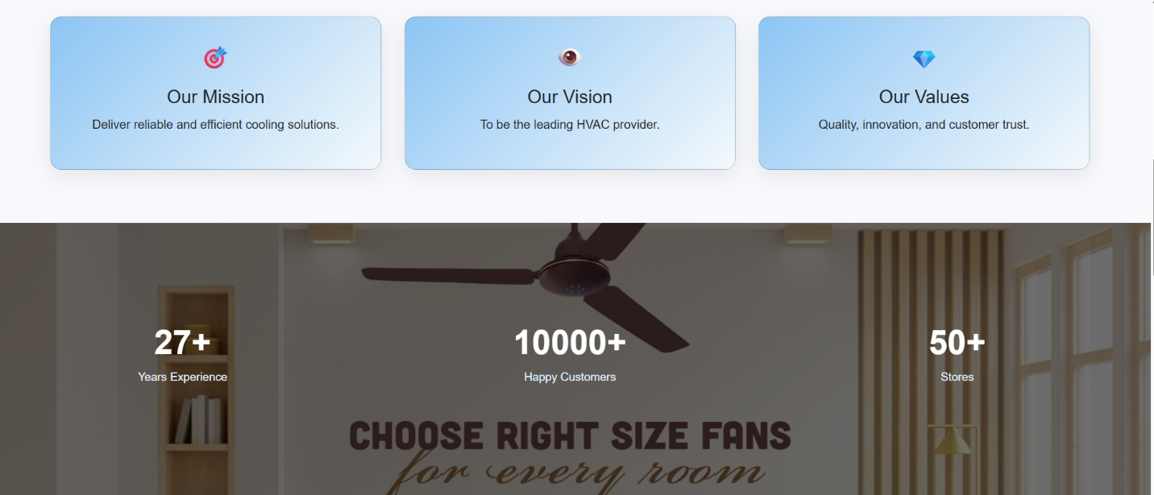
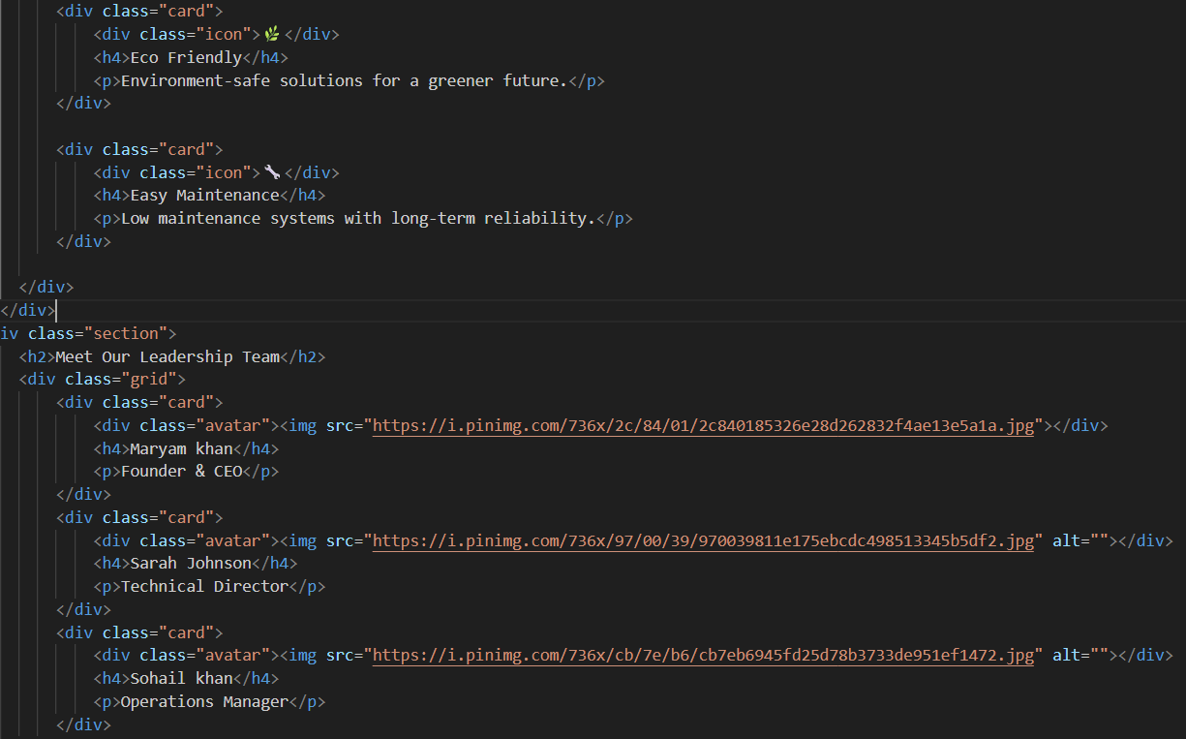

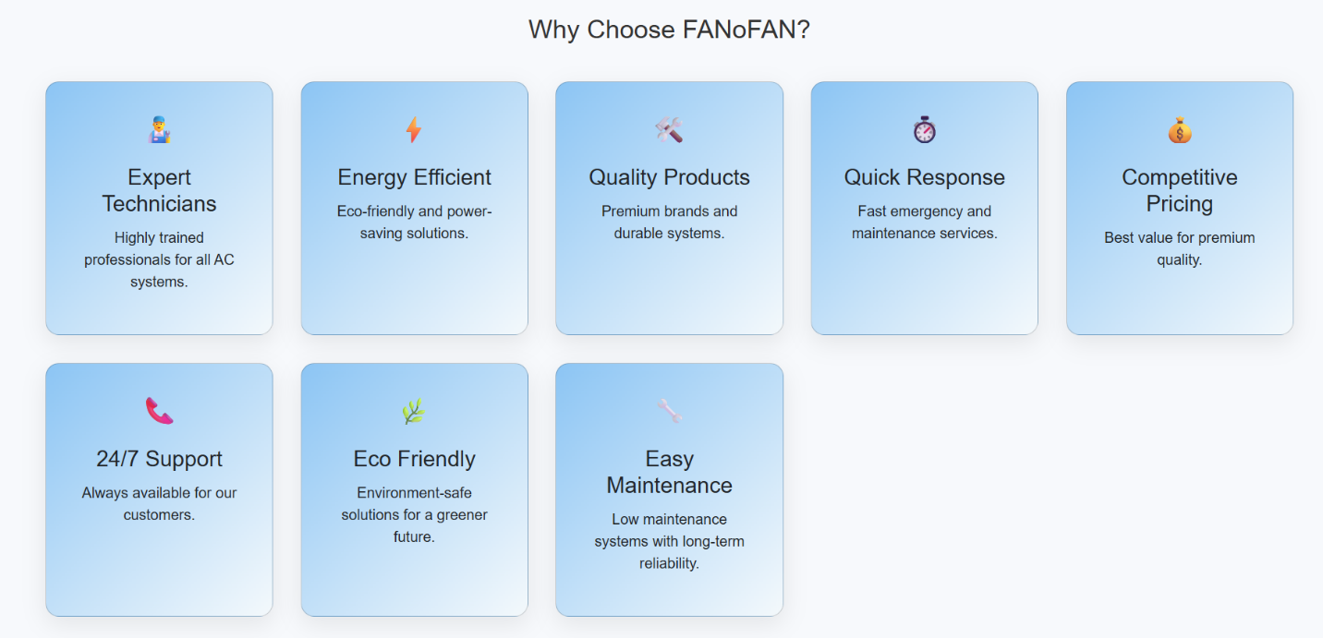

The About Us page provides information about the FANoFAN brand, its mission, and the purpose of the website. It introduces the company’s background, values, and commitment to providing high-quality fan designs and customer satisfaction. This page helps visitors understand who we are, what we offer, and why they can trust our products and services.

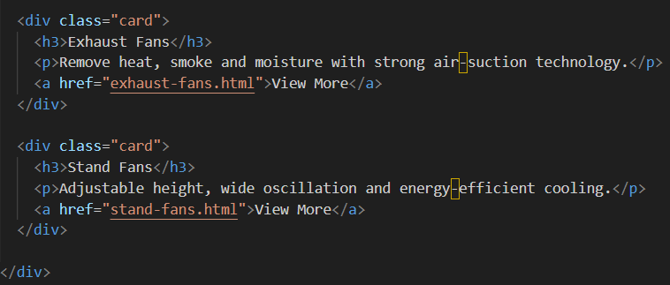
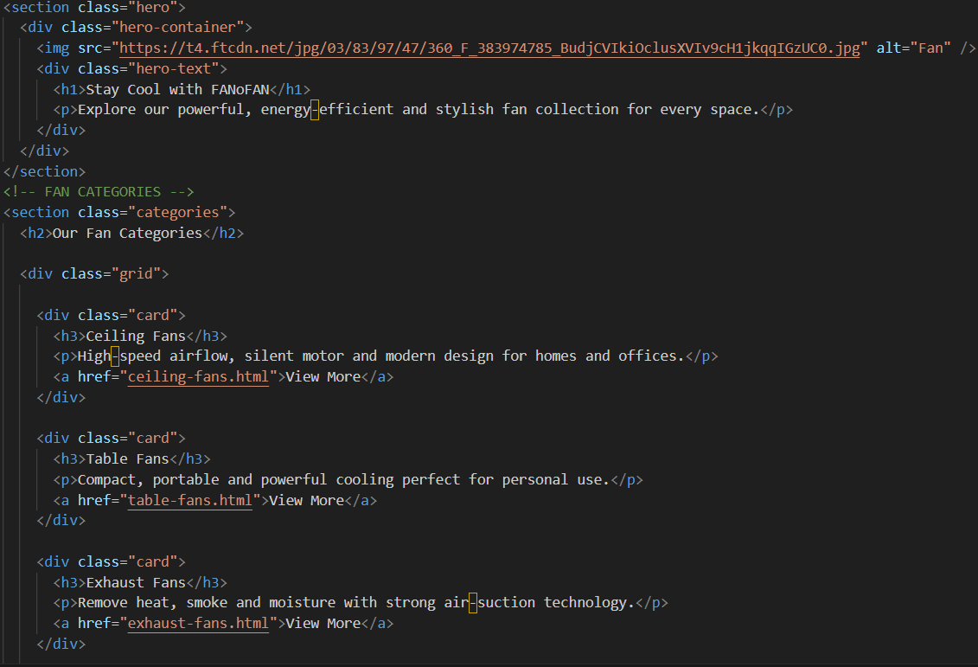
- Products(product.html)
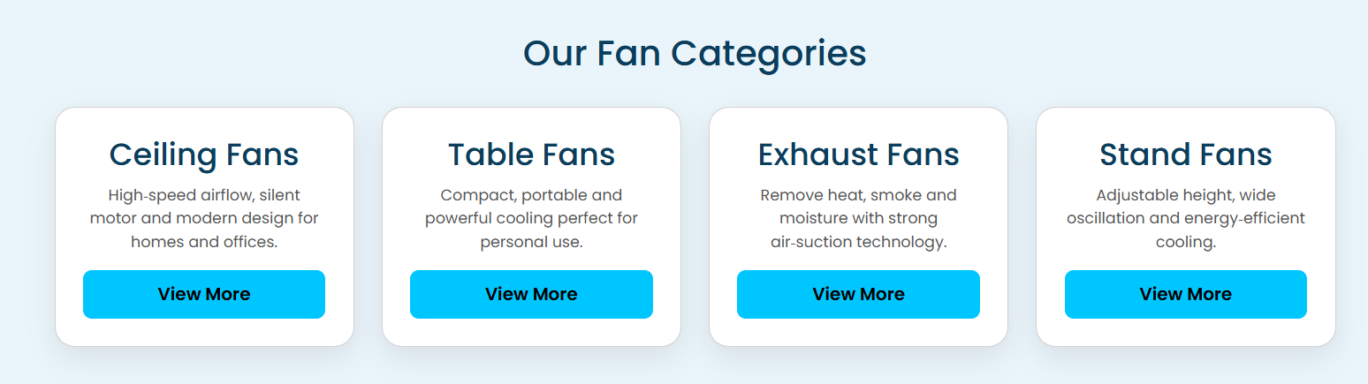
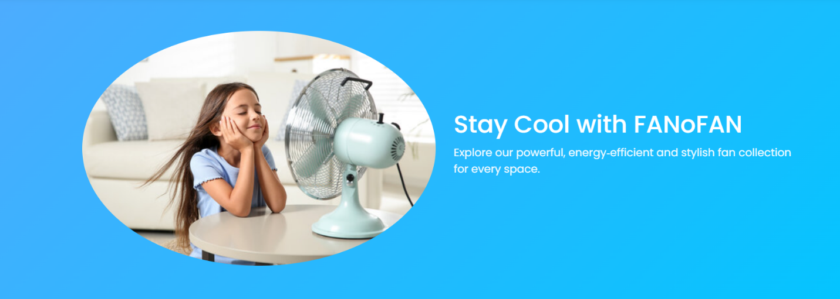
The Product Pages display different types of fans available on FANoFAN, including ceiling fans, exhaust fans, stand fans, and table fans. Each page shows clear images, details, features, and prices of the products. Users can view product specifications, add items to the cart, download product documents, and make informed choices easily. The pages are designed to be user-friendly and visually appealing to help customers explore and select the products they need.

- Ceiling Fan: Shows multiple designs, sizes, and prices; includes modal with details on click.
- Exhaust Fan: Displays different types for ventilation, with features and pricing.
- Stand Fan: Highlights portable fans with adjustable height and speed options.
- Table Fan: Shows compact fans suitable for desks or small spaces, with clear specifications.
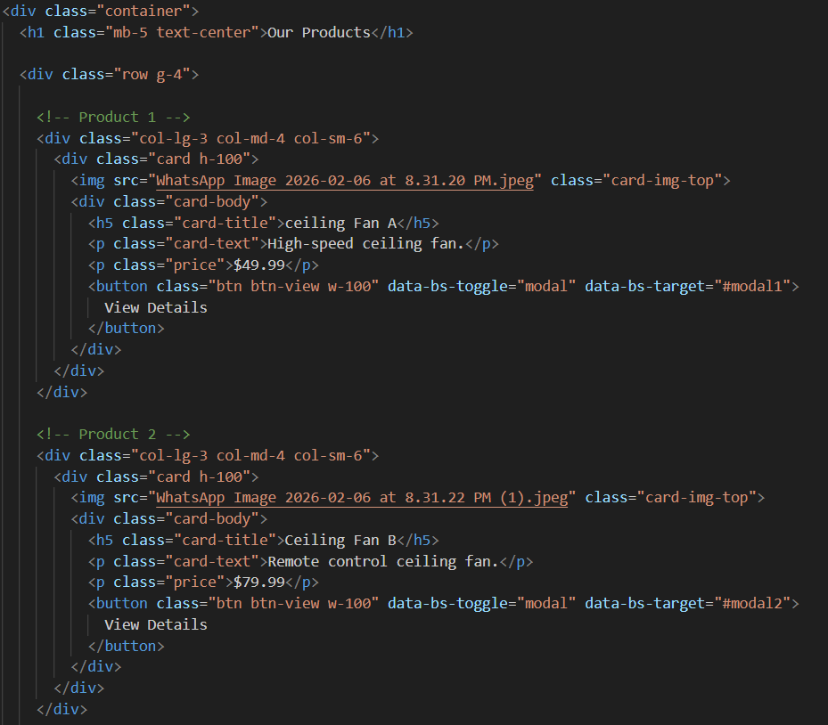
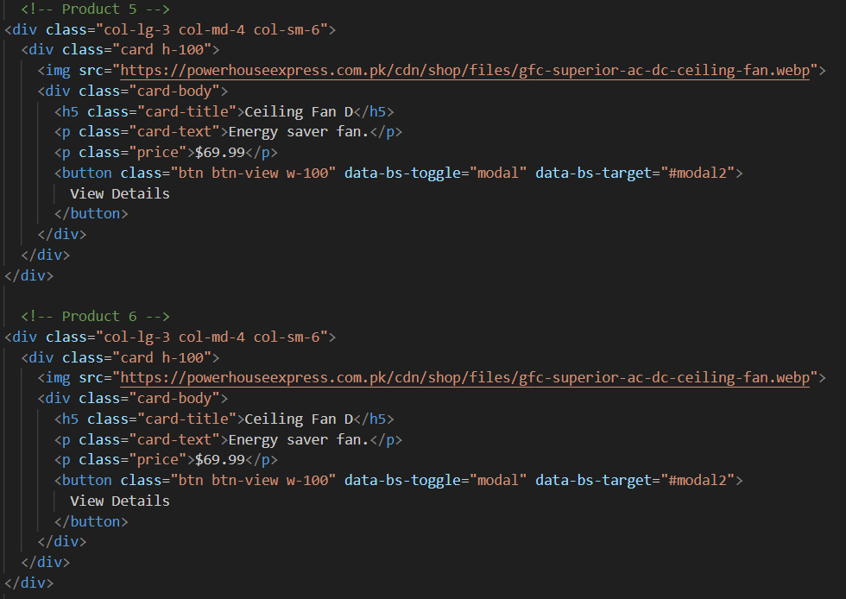
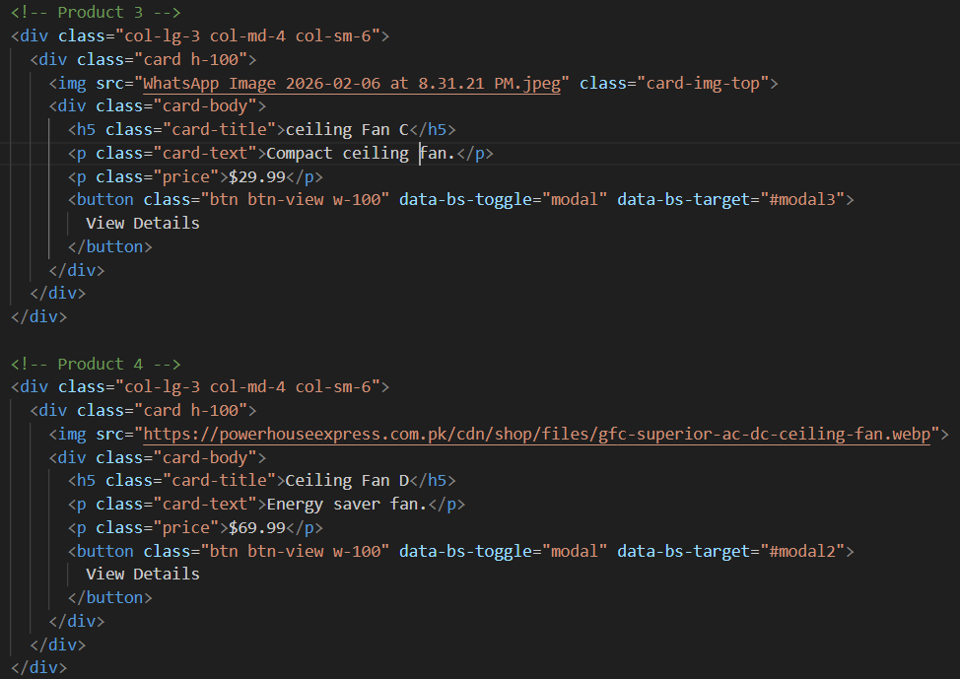
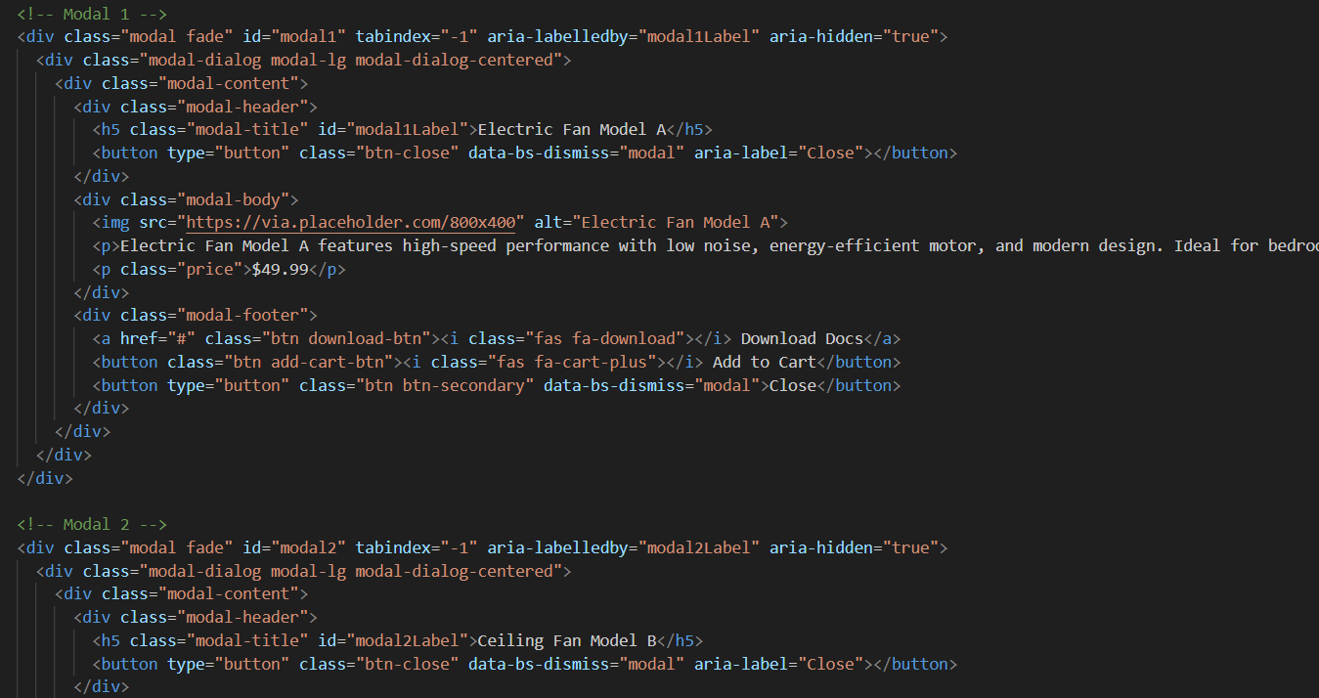
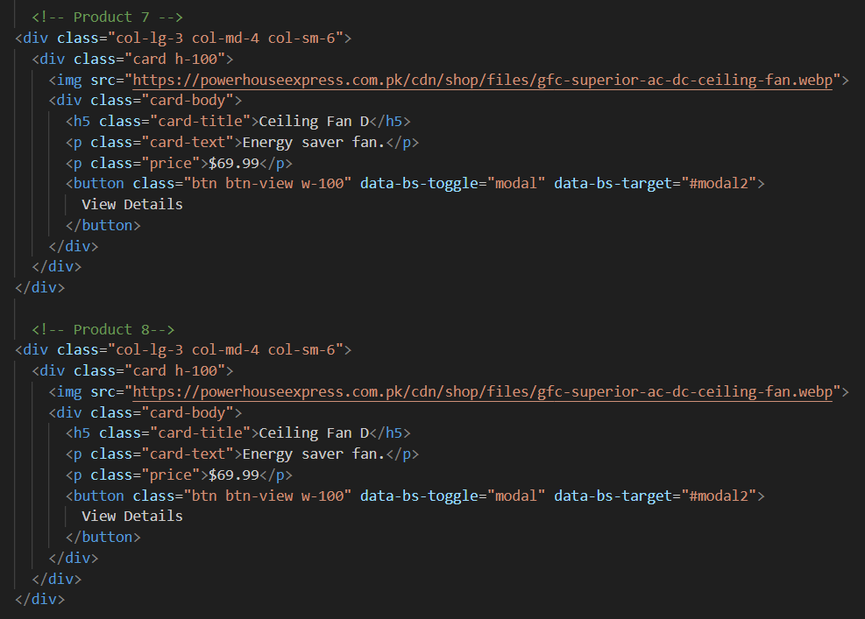
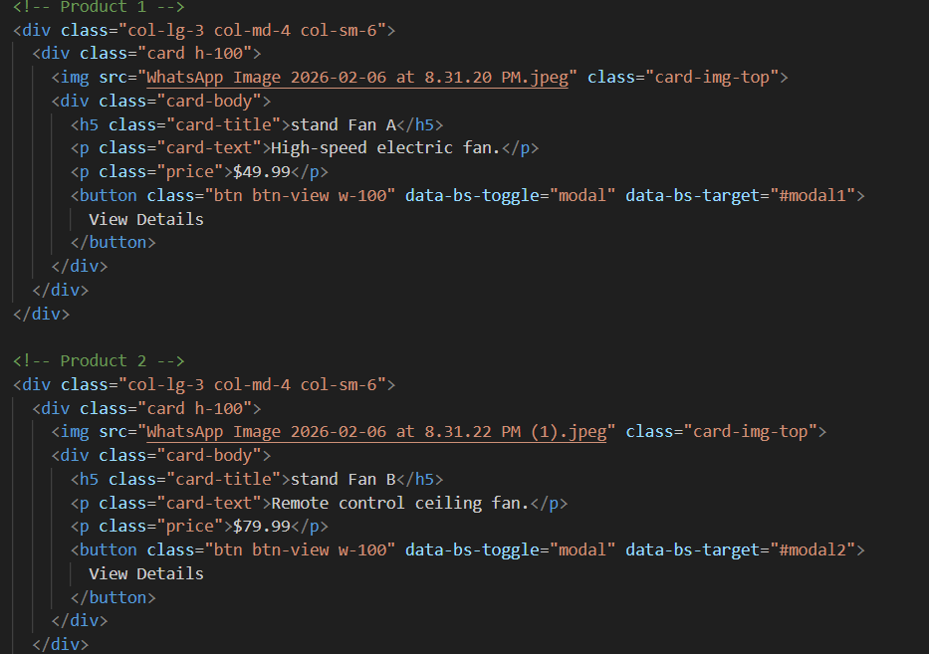

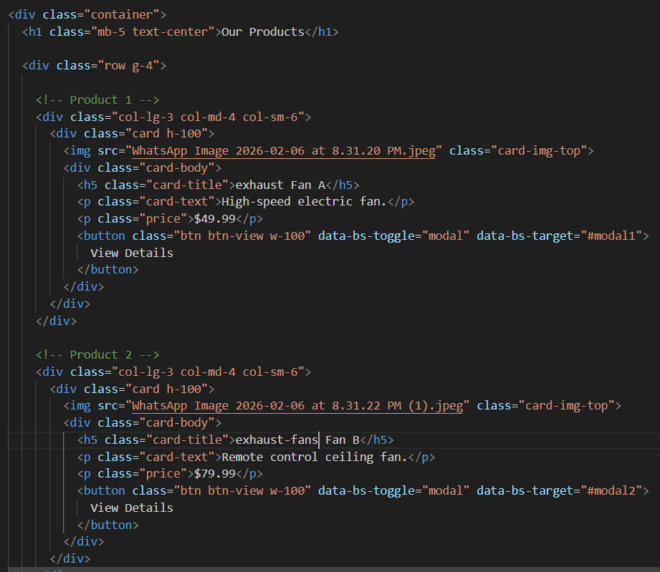

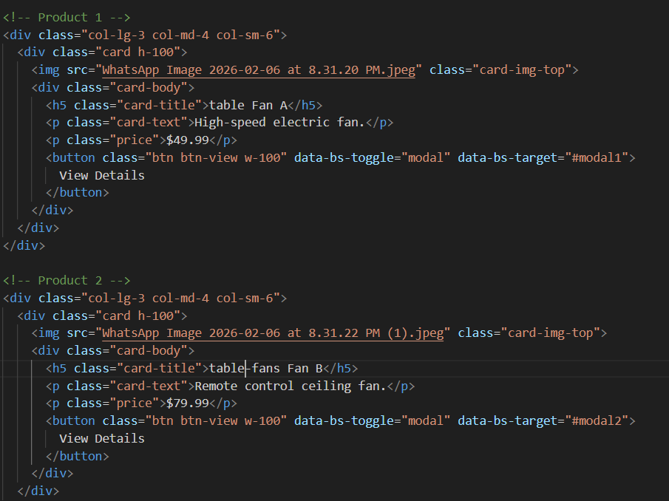
- Queries(queries.html)

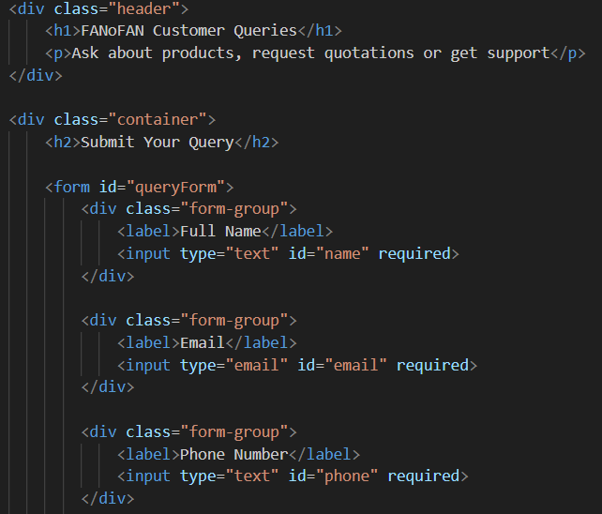

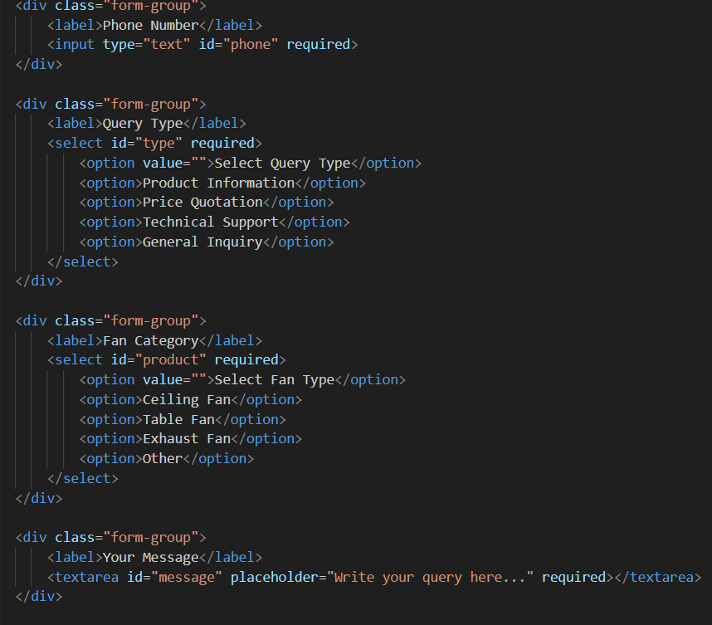

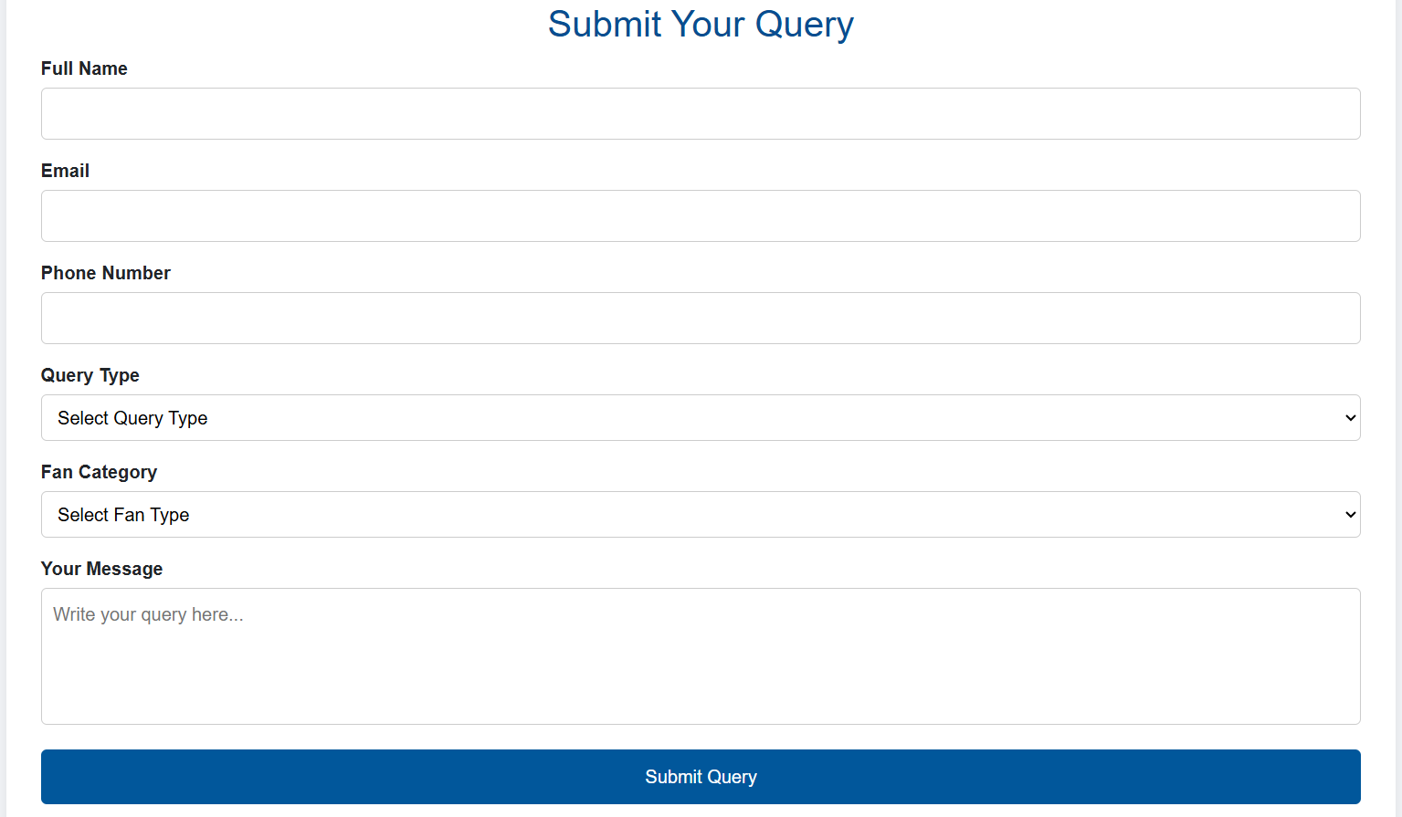
• Users can send their questions related to fans, prices, or products.
• A contact form is available to submit name, email, and message.
• Quick response system helps users get answers easily.
• Helps improve customer support and communication.
• Stores user queries for future reference and service improvement.

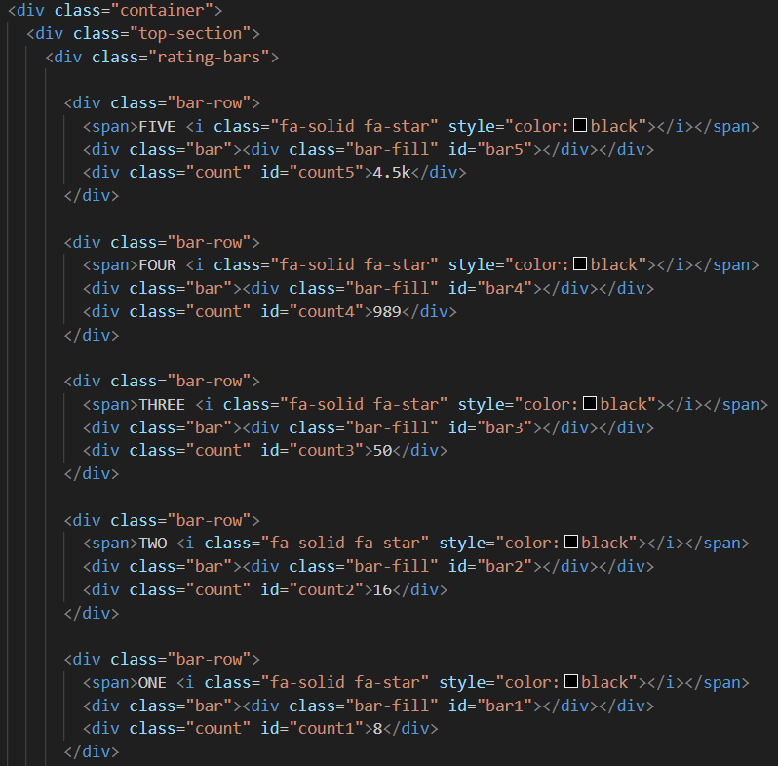
5.Feedback(feedback.html)

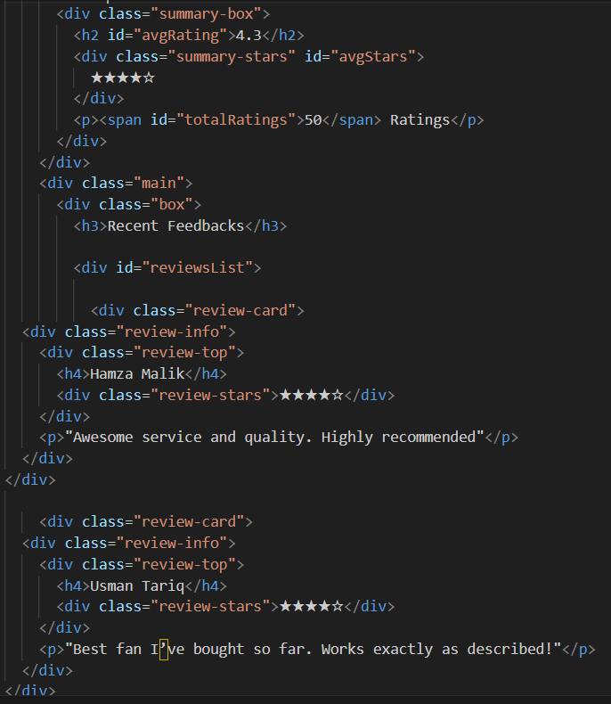


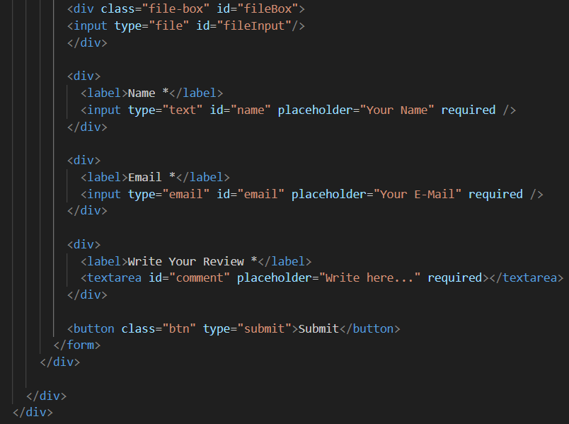

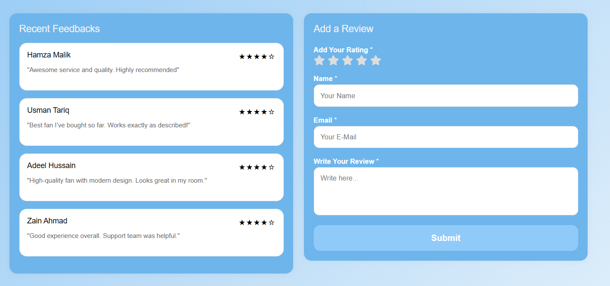
• Customers can share their experience about FANoFAN products.
• Feedback form allows rating, comments, and suggestions.
• Helps the company understand customer satisfaction level.
• Useful for improving product quality and website services.
• Builds trust and strong relationship with customers.

6.Gallery(gallery.html)
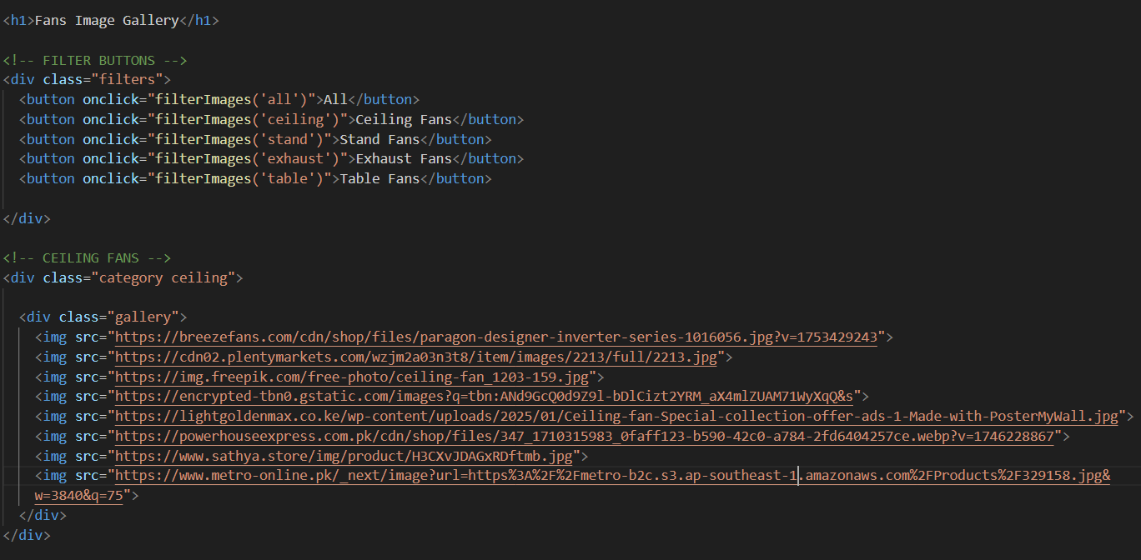
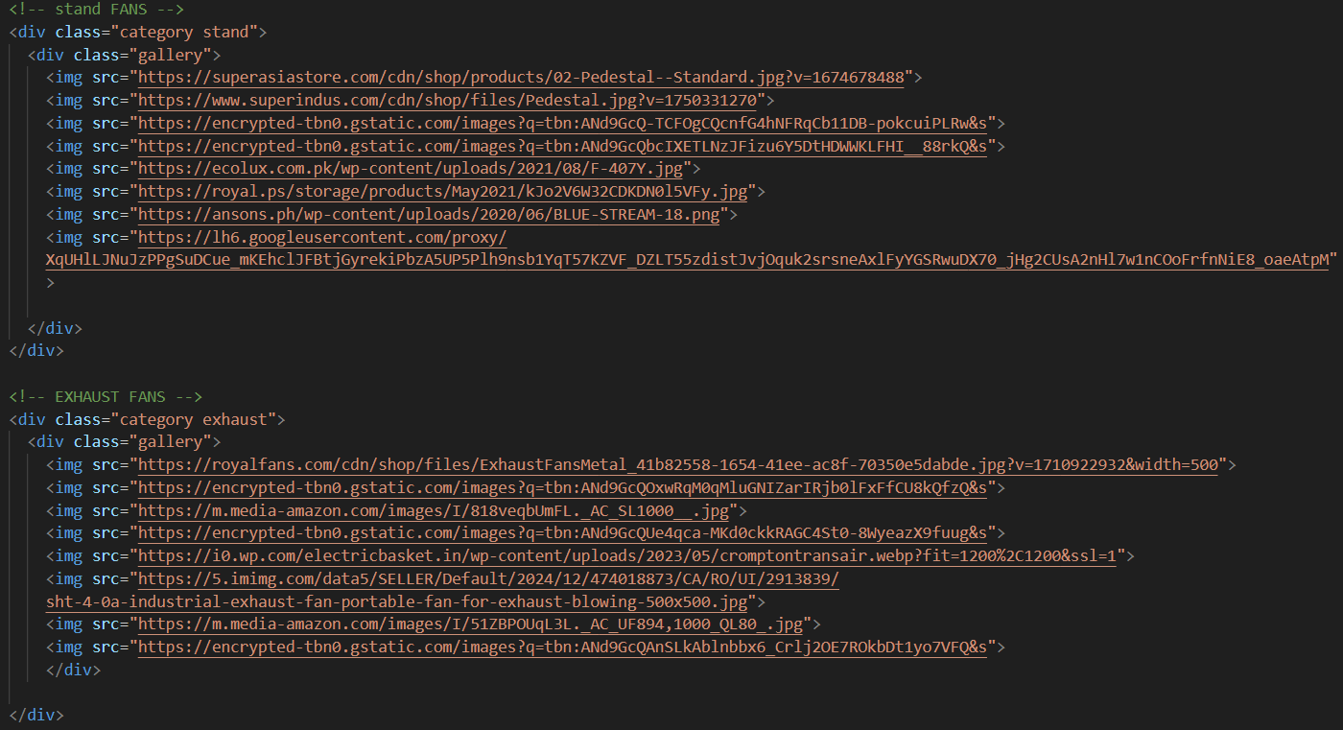
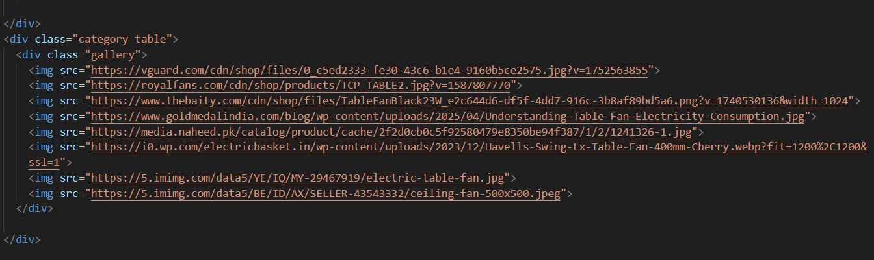

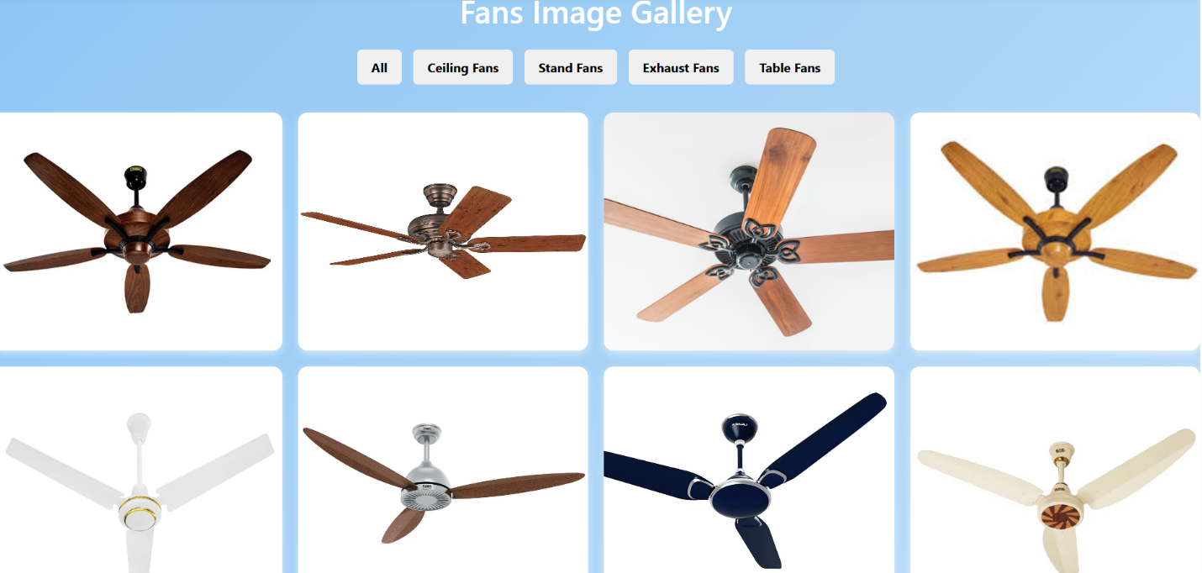

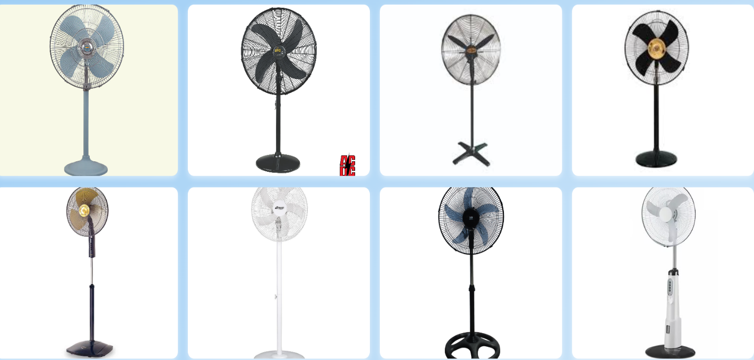
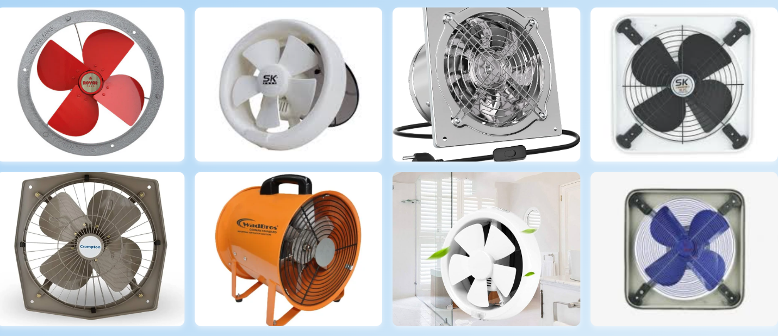

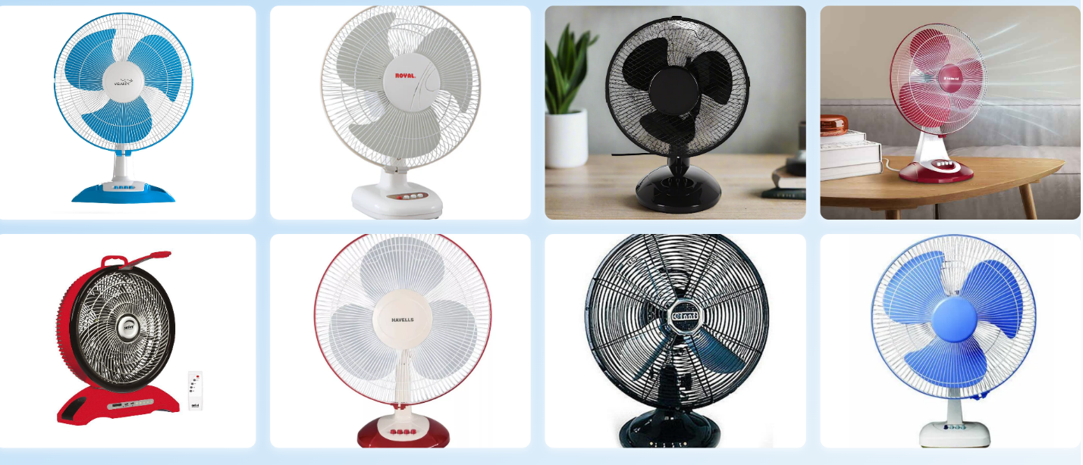
• Displays different types of FANoFAN fans in image form.
• Users can view product designs, colors, and styles easily.
• Images help customers choose the best fan according to their need.
• Gallery makes the website more attractive and informative.

7.Site Map(sitemap.html)

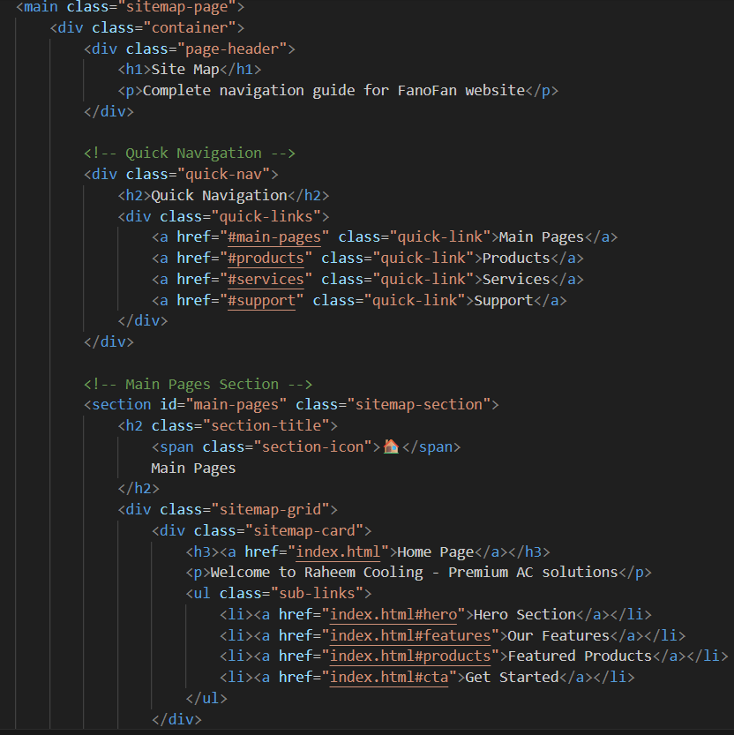

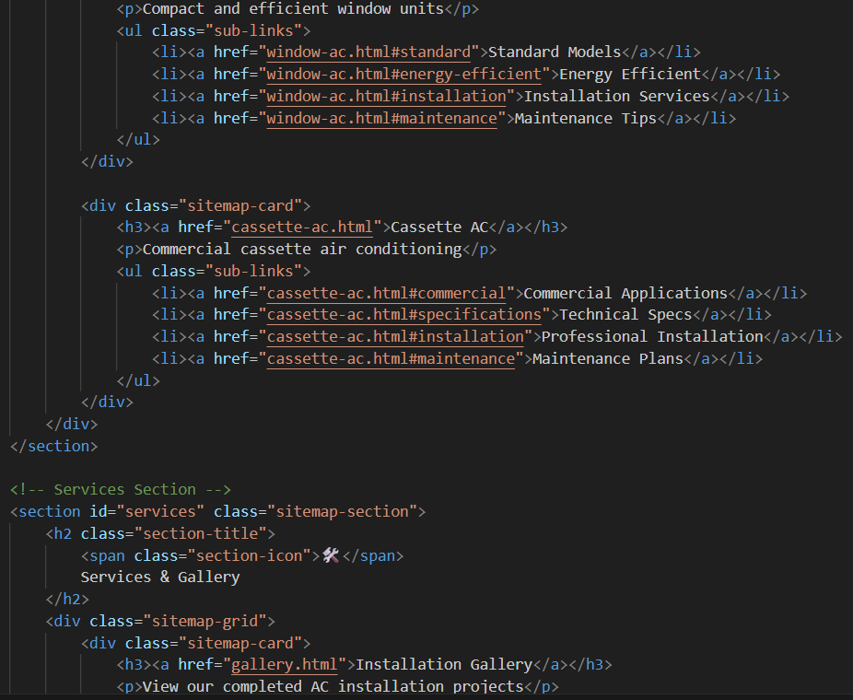
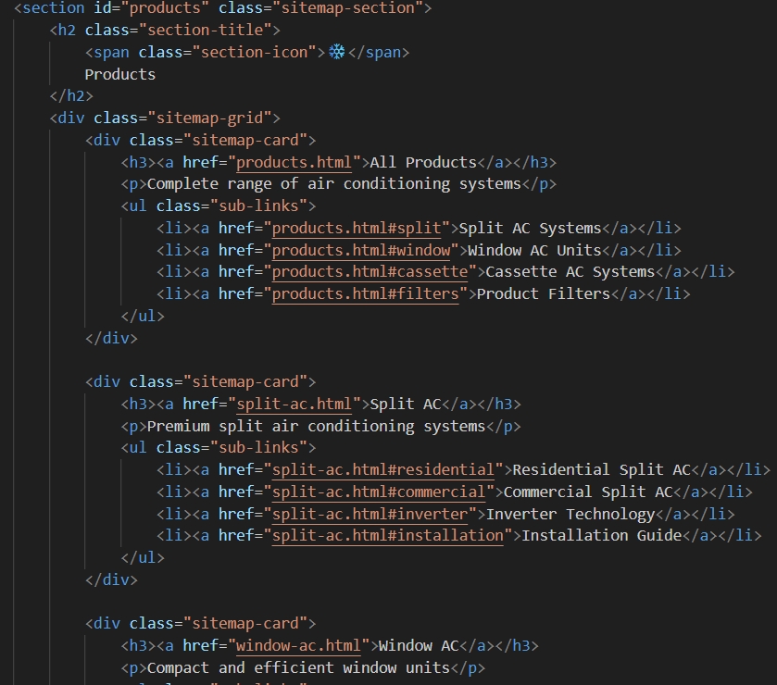
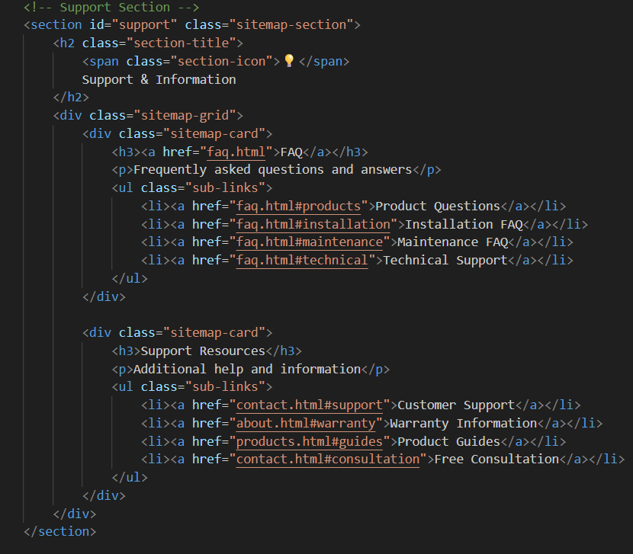

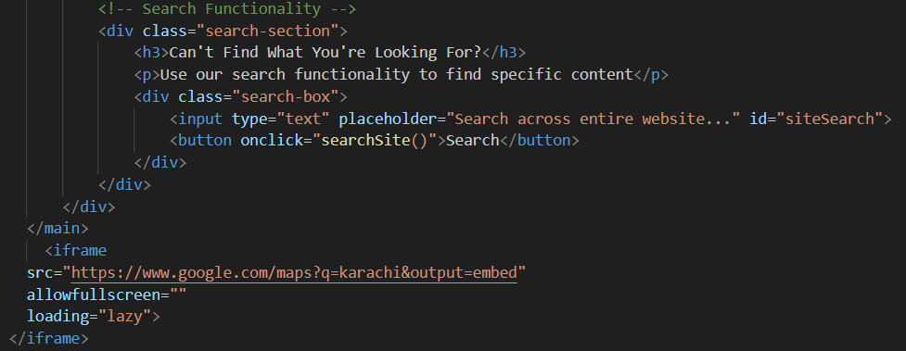
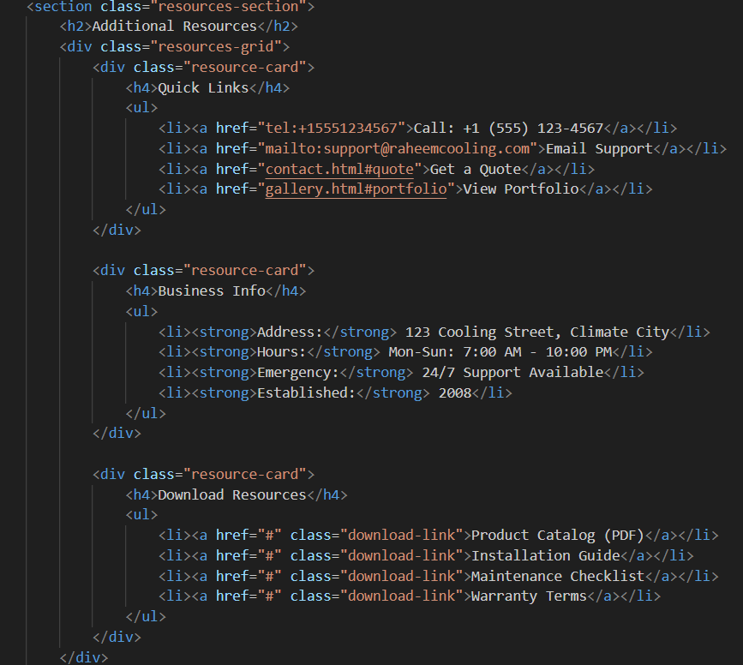

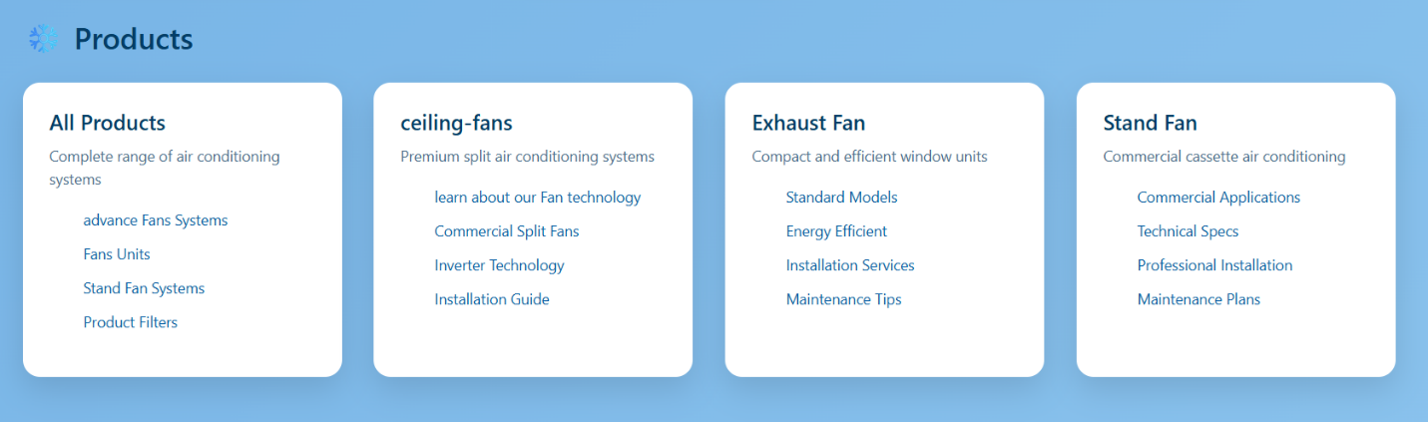
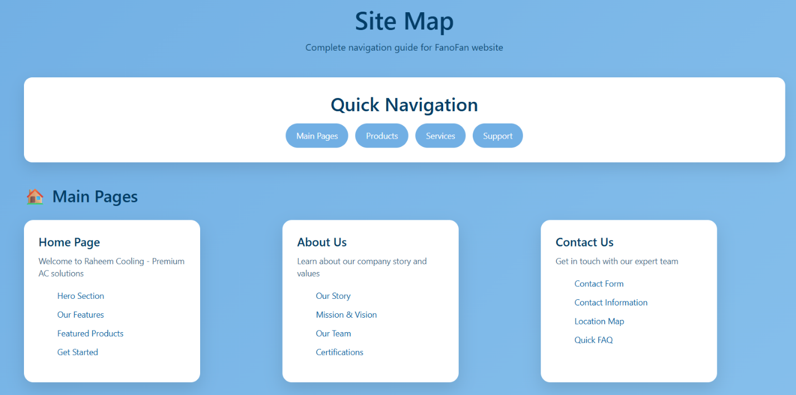

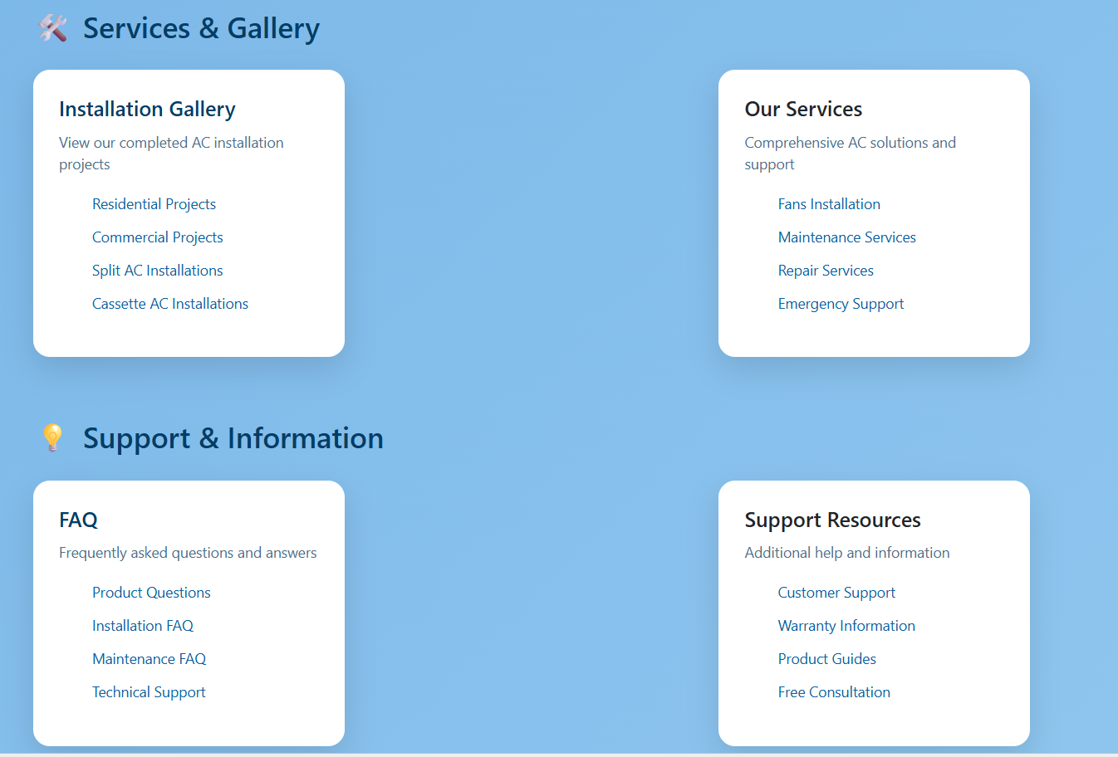
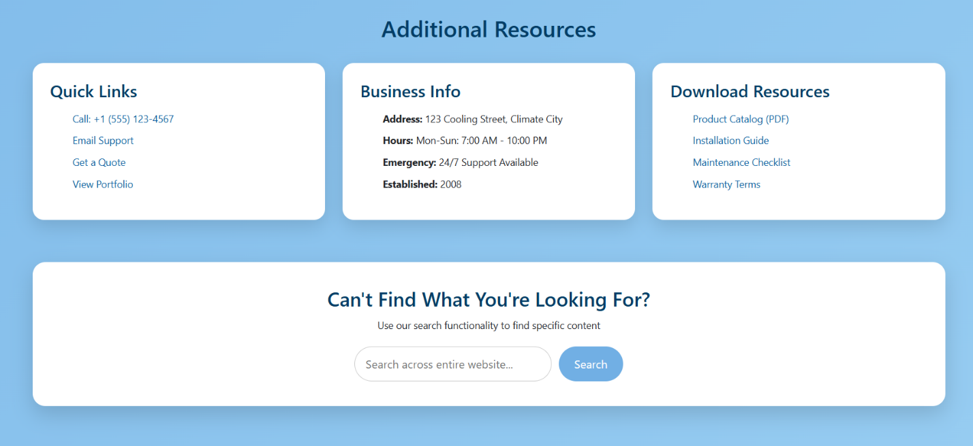
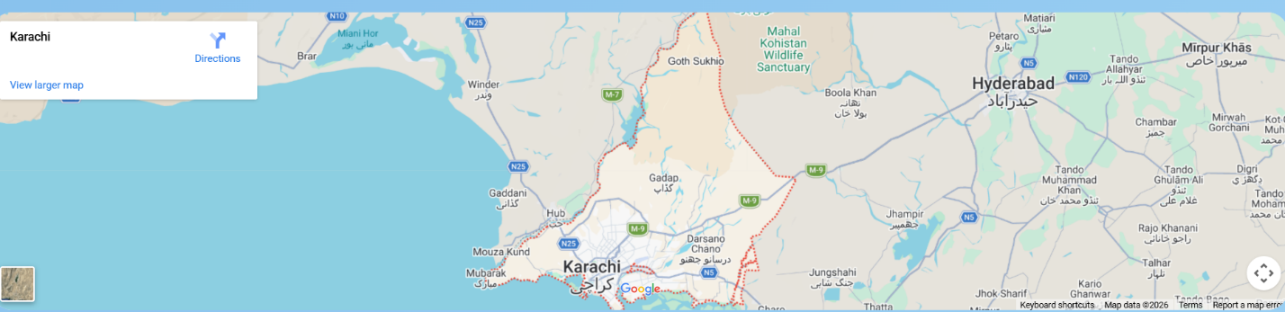
The Site Map page provides a clear and organized overview of all the main sections and pages available on the FANoFAN website. It helps users quickly find important pages such as Home, Products, Gallery, Queries, Feedback, and Contact without any confusion. By showing the complete website structure in one place, the site map improves navigation, saves time, and enhances the overall user experience. It also ensures that visitors can easily access the information they need about FANoFAN fans, services, and support.

8.Contact Us(contact.html)
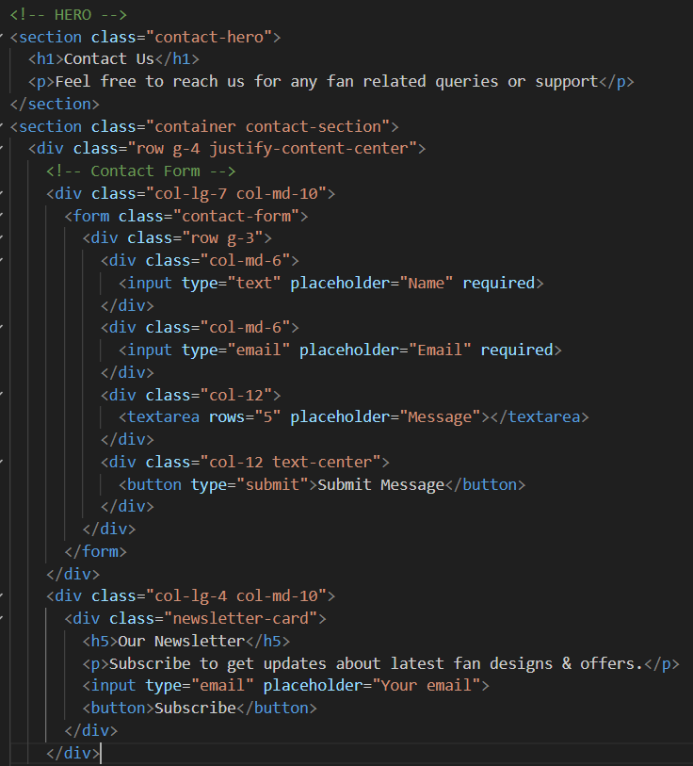

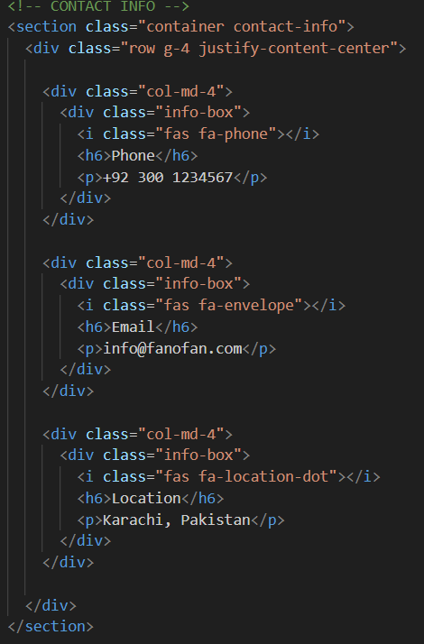

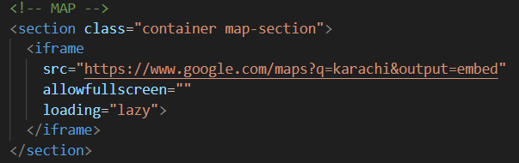
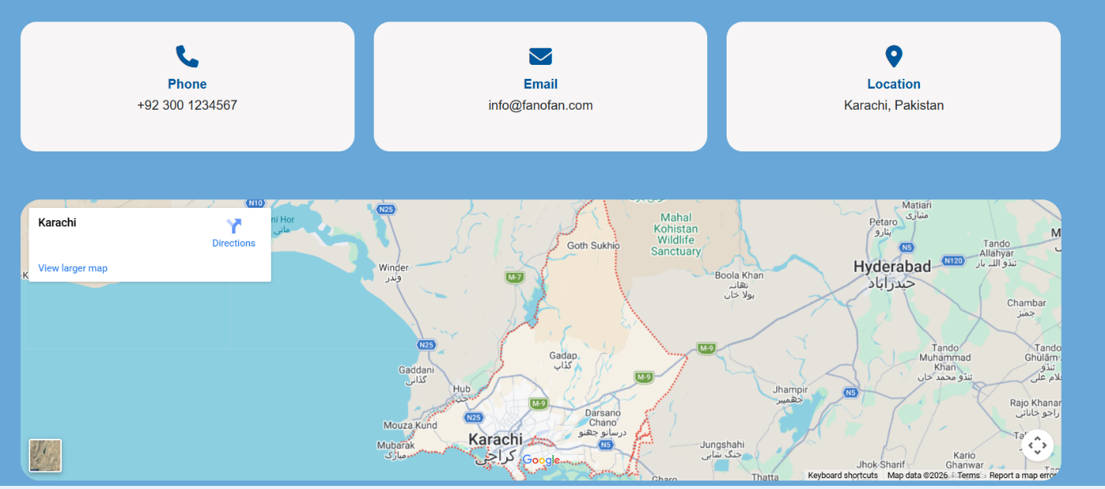
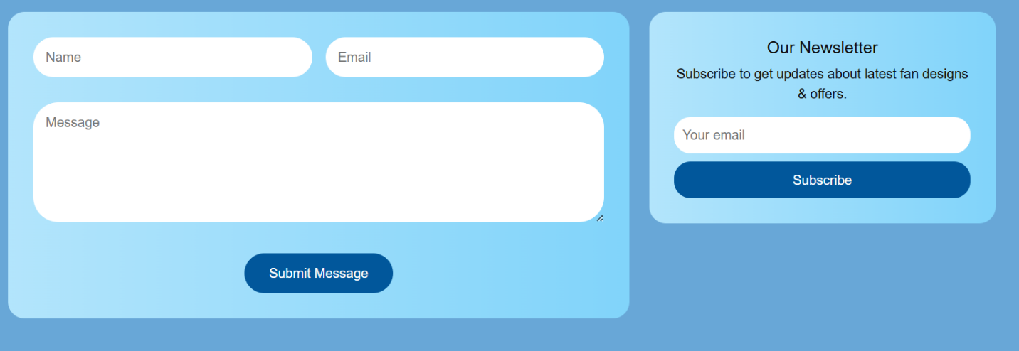


9.Footer
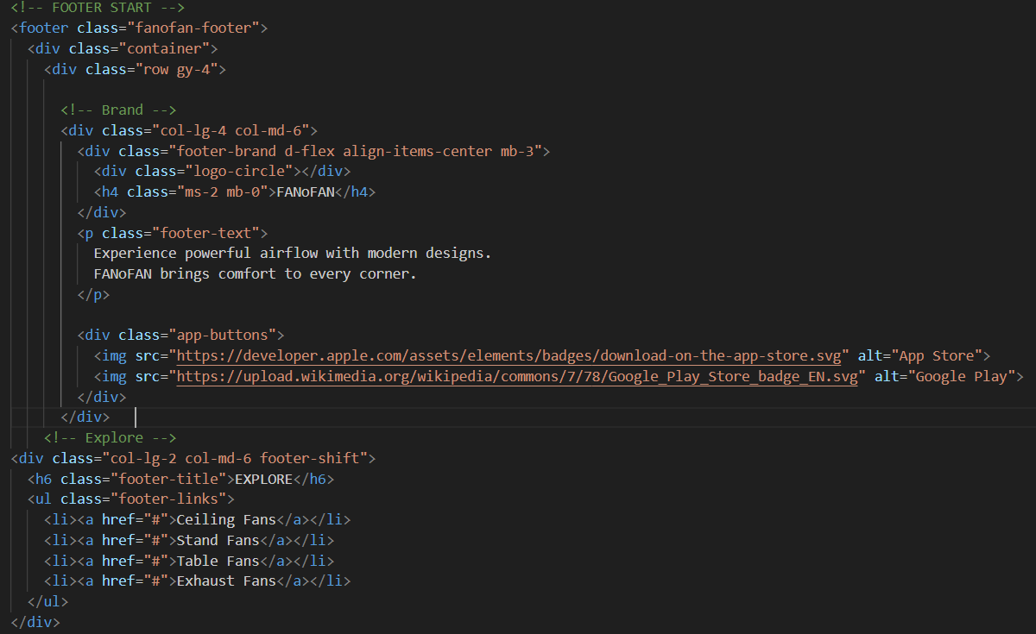

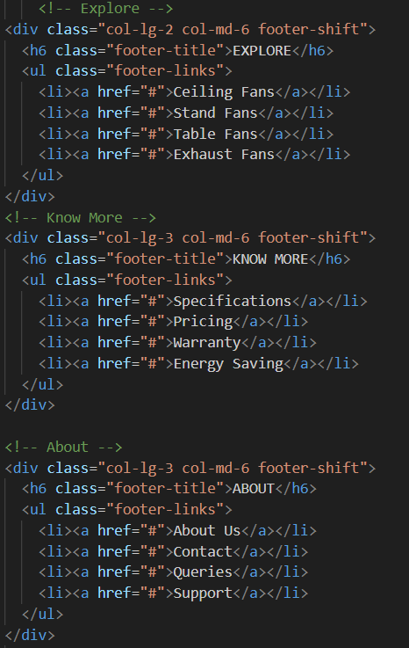

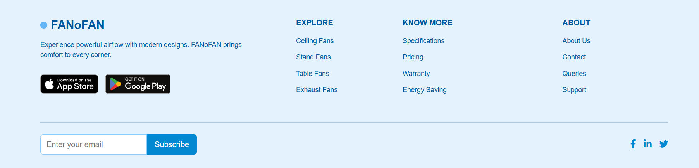
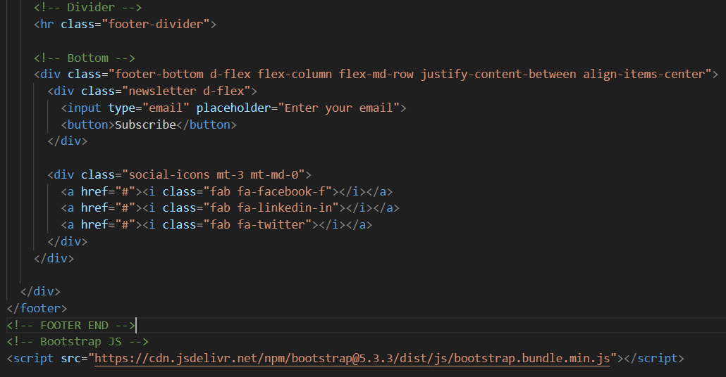
• The footer appears at the bottom of every page on the website.
• It contains important links such as Home, Products, Gallery, Queries, Feedback, and Contact.
• Shows company information, address, and contact details for user support.

